**Task 3: Importing Python modules and packages in python programming**

**Aim**:

To write python demonstrating importing Python modules and packages

1. **You are tasked with developing a modular calculator application in Python. The calculator should support basic arithmetic operations: addition, subtraction, multiplication, and division. Each operation should be implemented in a separate module. Additionally, you should create a main program to handle user input, call the appropriate module, and display the results.**

**Algorithm:**

1. Define functions for addition, subtraction, multiplication, and division.
2. Handle division by zero by raising an error if the divisor is zero.
3. Import the module (mymath) containing these functions.
4. Initialize two numbers (a = 10, b = 5).
5. Call each function using mymath.<function_name>(a, b).
6. Print the results of all operations.

**Program:**

def add(a, b):

return a + b

def subtract(a, b):

return a - b

def multiply(a, b):

return a * b

def divide(a, b):

if b == 0:

raise ValueError("Cannot divide by zero")

return a / b

import mymath

a = 10

b = 5

print("Addition:", mymath.add(a, b))

print("Subtraction:", mymath.subtract(a, b))

print("Multiplication:", mymath.multiply(a, b))

print("Division:", mymath.divide(a, b))

**Output:**

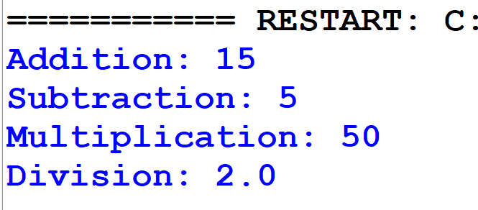

1. **You are working on a Python project that requires you to perform various mathematical operations and geometric area calculations. To organize your code better, you decide to create a package named mypackage which includes sub packages pack1 and pack 2 with two modules: mathfunctions and areafunctions Demonstrate the use of the functions by performing a few calculations and printing the results.**

**Algorithm:**

1. Create mathfunctions.py module:
2. Create areafunctions.py module:
3. Create __init__.py files in pack1 and pack2:
4. Create main.py:
5. Print the output as expected.

**Program:**

1. Create the mathfunctions.py module

def add(a, b):

return a + b

def subtract(a, b):

return a - b

def multiply(a, b):

return a * b

def divide(a, b):

if b == 0:

return "Error! Division by zero."

return a / b

1. Create the areafunctions.py module

import math

def circle_area(radius):

return math.pi * radius * radius

def rectangle_area(length, width):

return length * width

def triangle_area(base, height):

return 0.5 * base * height

1. Create __init__.py in each package folder (pack1 and pack2)

from .mathfunctions import add, subtract, multiply, divide

from .areafunctions import circle_area, rectangle_area, triangle_area

1. Create the main.py file

from pack import mathfunctions

from pack import areafunctions

# Using math functions

print("Addition:", mathfunctions.add(10, 5))

print("Subtraction:", mathfunctions.subtract(10, 5))

print("Multiplication:", mathfunctions.multiply(10, 5))

print("Division:", mathfunctions.divide(10, 5))

# Using area functions

print("Circle Area (radius=7):", areafunctions.circle_area(7))

print("Rectangle Area (5x10):", areafunctions.rectangle_area(5, 10))

print("Triangle Area (base=6, height=8):", areafunctions.triangle_area(6, 8))

**Output:**

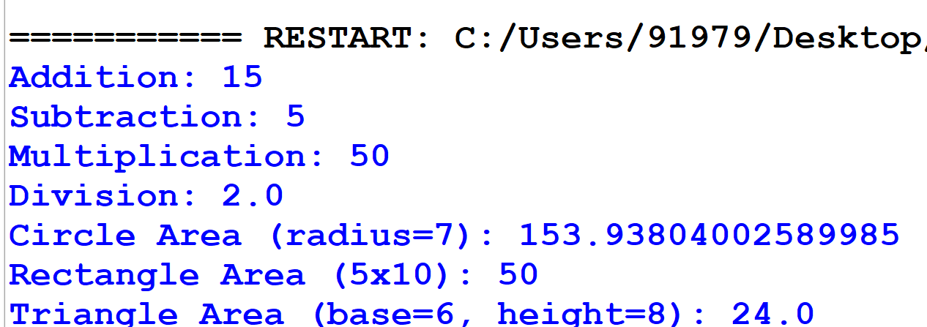

**Result:**

Thus, the program for Importing Python modules and packages was successfully executed and the output was verified.